

**EB5102 Data Analytics**:

**Bike Sharing Assignment**

**Lecturer:** Dr. Barry Adrian Shepherd

|  |  |  |
| --- | --- | --- |
| **Student ID** | **Name** | **E-mail** |
| A0178551X | Choo Ming Hui Raymond | [e0267862@u.nus.edu](mailto:e0267862@u.nus.edu) |
| A0178431A | Huang Qingyi | [e0267742@u.nus.edu](mailto:e0267742@u.nus.edu) |
| A0178415Y | Jiang Zhiyuan | [e0267726@u.nus.edu](mailto:e0267726@u.nus.edu) |
| A0178365R | Wang Jingli | [e0267676@u.nus.edu](mailto:e0267676@u.nus.edu) |
| A0178371X | Yang Shuting | e0267682@u.nus.edu |

# Table of Contents

Table of Contents 0

1. Introduction 1

2. Data Exploration 1

3. Feature Engineering 6

3.1 Target Redefinition 6

3.2 Feature Selection 7

3.3 New Feature Generation 7

4. Data Preparation 7

4.1 Split Training and Test Dataset 7

4.2 Standardization 8

4.3 Dummy Code 8

4.4 Outliers Transform 8

5. Modeling 8

5.1 Basic Model – Random Forest 10

5.2 Basic Model – Neural Network 10

5.3 Basic Model – Xgboost 10

5.4 Basic Model Comparison 10

5.5 Ensemble 10

6. Business Performance 11

7. Conclusion 11

Appendix A

# Executive Summary

## Results

|  |  |  |  |  |  |
| --- | --- | --- | --- | --- | --- |
|  |  |  |  | RMSE | |
| Model | Profit | Cost | Profit/Cost | Percentage Increase | Absolute Demand |
| $ million | $ million |
| benchmark | 145.9 | 408.5 | 35.7% | - | - |
| rf_best | 162.6 | 415.1 | 39.2% | 0.34 | 981 |
| nn_best | 166.8 | 389.6 | 42.8% | 0.32 | 980 |
| xgb_best | 167.7 | 391.3 | 42.9% | 0.35 | 983 |
| **blending** | **168.7** | **390.6** | **43.2%** | **0.33** | **949** |
| stacking | 164.9 | 368.7 | 44.7% | 0.36 | 1136 |

## Recommendations

# Introduction

# Data Exploration

Prior to using the dataset for analysis, a series of data exploration activities were carried out. The BikeSharing Dataset contains 16 variables, the description and available values of each variable are shown in data dictionary as below:

Table 1: Data Dictionary

|  |  |  |  |
| --- | --- | --- | --- |
| VariableNames | VariableType | Description | Value |
| instant | - | Index | - |
| dteday | DateTime | Date | - |
| season | Categorical | Season | 1:springer, 2:summer, 3:autumn, 4:winter |
| yr | Categorical | Year | 0: 2011, 1:2012 |
| mnth | Categorical | Month | 1 to 12 |
| holiday | Categorical | Hour | 0: not holiday, 1: holiday |
| weekday | Categorical | Weather | 0 to 6 |
| workingday | Categorical | If day is neither weekend nor holiday is 1, otherwise is 0 | 0: not working day, 1: working day |
| weathersit | Categorical | Weather Condition | 1: Clear, Few cloud, 2:Mist, cloudy, 3:Light Snow, rain, 4: Thunderstorm |
| temp | Numeric | Normalized temperature in Celsius. | - |
| atemp | Numeric | Normalized feeling temperature in Celsius | - |
| hum | Numeric | Normalized humidity | - |
| windspeed | Numeric | Normalized wind speed | - |
| casual | Numeric | Count of casual users | - |
| registered | Numeric | Count of registered users | - |
| cnt | Numeric | Count of total rental bikes including both casual and registered | - |

According to time-based distribution plots of all variables, several initial insights can be discovered. The patterns of *‘cnt’* and ‘registered’, which represent the total number of rental bikes and the count of registered users respectively are similar. It is also shown that these two variables increased steadily with some seasonal impacts on them from 2011 to 2012, while an abnormal drop of rental demand was observed on 29th October 2012 due to the destructive hurricane *‘Sandy’*. Compared to oscillation in *‘cnt’* and ‘registered’, the demand of casual users accounted only 20% of the total had a higher variance. In addition, *‘temp’* and *‘atemp’* moved synchronized with strong seasonality, and there were no patterns can be identified by observing records of humidity and wind speed.



Figure 1:Time-based Distribution of All Variables

To narrow focus on different types of variables, the following explorations were implemented. For numeric variables, confusion matrix and scatter plot were used to illustrate the relationships between explanatory variables and response variable. From Figure 2&3, relatively high correlation was found between *‘temp’, ‘atemp’* and *‘cnt’*. As such, ‘temp’ and *‘atemp’* can be remained for their strong predictive ability. However, *‘temp’* and *‘atemp’* are highly correlated, with a Pearson Correlation r equal to 0.99. To avoid multicollinearity, only *‘temp’* was remained in following analysis process.

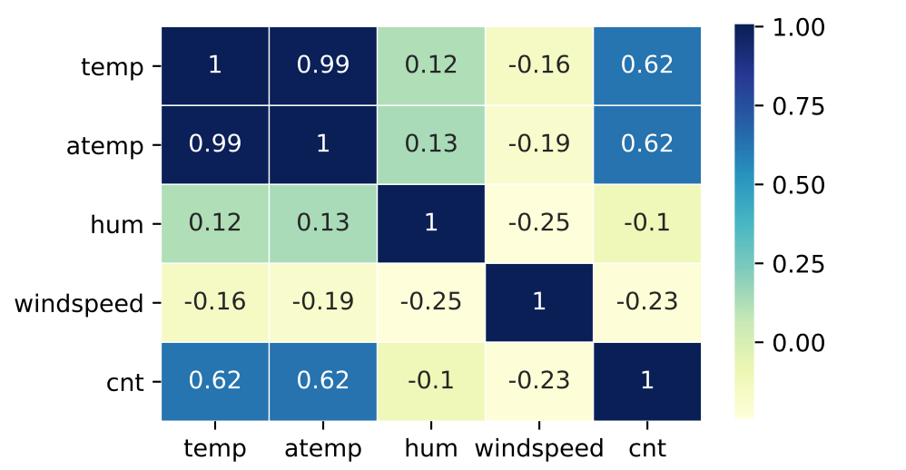

Figure 2: Confusion Matrix of Numeric Variables

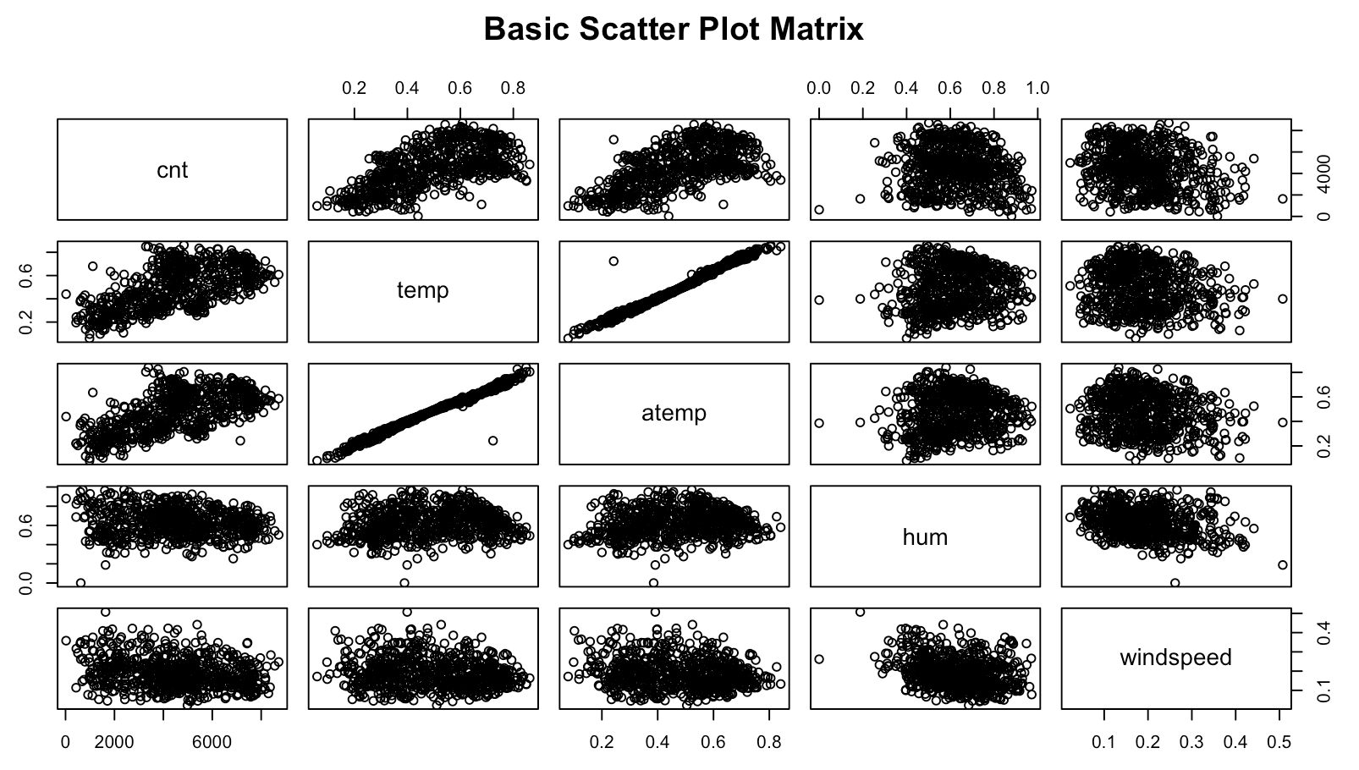

Figure 3: Scattor Plot of Numeric Variables

For categorical variables, scatter plot and boxplot were used to demonstrate the relationship between independent and depend variables. The Scatter Plot of daily bicycle demand was filled based on different weather type and most outliers were low values colored in blue, which related to lightly rainy days. This indicates that people are less likely to commute by bike, if it is a rainy day.



Figure 4: Scatter Plot of *‘weathersit’*

The same in finding also is also illustrated in Figure 5. The demand under different weather status concentrated on different levels, and a significantly lower number of bikes were rented when there was a lightly rainy/ snowy day (*‘type 3’ weathersit*).



Figure 5: Boxplot of *‘weathersit’*

According to the data dictionary, there were four types of weather conditions defined in the *‘weathersit’* attribute. However, records of *‘type 4’* which refers to extreme weather conditions, including heavy rain, snowstorm and ice pallets were not included in this dataset. Referred to weather reports online [1][2], it is proven that *‘type 4’* weather conditions did occur on few days in Washington DC during this 2-year period. As such, the original *‘weathersit’* values of days having severe weather events were switched to *‘type 4’* as Table 2 shown below.

Table 2: Extreme Weather Events in Washington DC, 2011-2012

|  |  |  |  |
| --- | --- | --- | --- |
| Date | Weather | OriginalWeathersit | ModifiedWeathersit |
| 26/01/2011 | winter storm, heavy snow | 3 | 4 |
| 16/04/2011 | tornado outbreaks, thunderstorm | 3 | 4 |
| 07/09/2011 | tropical storm Lee | 3 | 4 |
| 08/09/2011 | tropical storm Lee | 3 | 4 |
| 29/10/2011 | heavy rain | 3 | 4 |
| 07/12/2011 | recored breaking rain storm | 3 | 4 |
| 22/04/2012 | light rain, fog | 2 | 3 |
| 29/10/2012 | sandy storm | 3 | 4 |
| 30/10/2012 | sandy storm | 3 | 4 |
| 26/12/2012 | winter storm, heavy snow | 3 | 4 |

Figure 6 shows that the gap of the total rental demand on working days and non-working days was narrow, while registered users were more likely to rent bikes on working days. In contract, for casual users, the demand on holidays and weekends were much higher than the demand on working days, especially on summer and autumn.



Figure 6: Line Graph of *‘workingday’*

In conclusion, at data exploration phase, based on findings mentioned above, the demand of registered and casual users is suggested to be predicted separately for the different patterns they have. And the total demand of rental bikes is equal to the sum of count of these two categories.

# Feature Engineering

Table 3: Selected Variables after Feature Engineering

|  |  |  |  |
| --- | --- | --- | --- |
| VariableTypes | NewVariables | VariableName | Definition |
| Target | ✓ | cnt_inc_ratio | Percentage Increase of Dt demand against Dt-2 |
| Categorical |  | workingday | If Dt is workingday |
| Categorical |  | weathersit | Weather condition of Dt |
| Categorical |  | weekday | If Dt is weekday |
| Categorical |  | season | Season of Dt |
| Numeric | ✓ | cnt_inc_ratio_lag2 | Percentage Increase of Dt-2 demand against Dt-4 |
| Numeric | ✓ | cnt_inc_ratio_weekly_avg | Percentage Increase of Dt-2 demand against the average demand of Dt-2 to Dt-7 |
| Numeric | ✓ | cnt_inc_ratio_monthly_avg | Percentage Increase of Dt-2 demand against the average demand of Dt-2 to Dt-30 |
| Numeric | ✓ | cnt_inc_ratio_weekly_max | The percentage increase of Dt-2 demand against the maximum demand among Dt-3 and Dt-8 |
| Numeric | ✓ | cnt_inc_ratio_weekly_min | The percentage increase of Dt-2 demand against the minimum demand among Dt-3 and Dt-8 |
| Numeric | ✓ | temp_inc | Percentage Increase of Dt-2 demand against Dt-4 |
| Numeric | ✓ | cnt_avg_aheadWeek | demand of the ahead week’s average among Dt-2 and Dt-7 |
| Numeric | ✓ | cnt_avg_ahead3days | Ahead 3days average demand among Dt-2 and Dt-4 |
| Numeric | ✓ | cnt_avg_aheadMonth | Ahead 1 month average demand among Dt-2 and Dt-31 |
| Numeric | ✓ | cnt_median_LastWeek | median demand of ahead 1 week among Dt-2 and Dt-7 |
| Numeric | ✓ | cnt_lastWeekday | demand of ahead 1 weekday |

## Target Redefinition

In the general sense, regression models are able to take variable inputs and predict an output from a continuous range. However, tree-based regressions are not capable of producing continuous output. Training examples are partitioned in trees and new examples that end in a given node will take on the mean of the training example values that reside in the same node. Thus, outputs from tree-based models are discrete and have a similar range as the response variable of the training set. Based on the initial insight gained from data exploration that the count of rental bikes had an increased trend, if the absolute demand was set as the target variable, predictive results would not exceed the highest demand in the training dataset, which limits the model’s predictive ability. Considering the limitation of tree-based regression algorithm, the target in this case was changed from predicting the absolute demand of rental bikes to estimating the percentage increase of the demand.

From another aspect, transforming the target to percentage increase can eliminate the time-related increasing trend of the rental demand, converting the series into a stationary time series.

## Feature Selection

Considering the findings after data exploration as well as the feature importance outcome of RFECV shown in Table xx, only 4 categorical variables were remained in the next modeling stage, including *‘workdingday’, ‘weathersit’, ‘season’,* and *‘weekday’*. Based on the assumptions that weather condition of $D_{t}$ can be known from weather forecast on $D_{t-1}$, the actual values of these four variables on $D_{t}$ were used as inputs to predict the demand percentage increase on $D_{t}$.

## New Feature Generation

As the objective had been changed to predicting the percentage increase, it is reasonable to convert input variables from absolute numbers to percentage as well. In general, the more the data present the stronger predictive power it has. However, $D_{t-1}$ demand-related data cannot be used to predict $D_{t}$ value since it would be incomplete at 4pm, by which the forecast mush be made. As such, new variables ‘*cnt_inc_ratio_lag2*’, ‘*cnt_inc_ratio_weekly*’ and ‘*cnt_inc_ratio_monthly_avg*’ was created based on $D_{t-2}$ value. In addition, in order to reflect the patterns that might be offset by averaging the weekly data, ‘*cnt_inc_ratio_monthly_max*’ and ‘*cnt_inc_ratio_monthly_min*’ were created. The specific definition of new features was shown in Table 3.

# Data Preparation

## Split Training and Test Dataset

In this case, only one model was built and apply to all days in the test set with no model updating overtime. Since this is a time-based dataset, the sequence between data points should be remained. Thus, this 2-year dataset was split into training and test, with records from 1st January 2011 to 31th December 2011 and 1st January 2012 to 31th December 2012 respectively.

## Standardization

Since independent variables had been changed to from absolute demand to percentage increase which means that they are all in the same scale, there was no need to implement standardization in this case.

## Dummy Code

There were three learning algorithms applied to predict the demand of sharing bikes, including neural networks, random forest and xgboost. Therefore, input variables should be preprocessed differently according to algorithms. For neural networks, explanatory variables are required to be numeric. As such, for categorical variables where no ordinal relationship exists, dummy code is required to be applied, by which a new binary variable is added for each unique category. In this case, xx categorical variables were encoding into xx new binary variables, while each category of ordinal variables was represented by an integer value. In contrast, tree-based algorithms can deal with categorical variables without this preprocessing step.

## Outliers Transform

In this case, it is reasonable to assume that tomorrow’s ($D_{t}$) weather condition can be known from weather forecast. Thus, if it forecasts that there will be a natural disaster tomorrow, liked “Sandy” on 29th October 2012, we assume that the company would not loan any bike from its supplier BulkBike. This is how the outliers of an extreme low demand of 22 bikes on that day was pre-processed in this case.

# Modeling

In the first phase of modeling, three basic models including Random Forest, Neural Network and Xgboost were designed. Each individual model was built using sets of different variables shown in Table xx, which were chosen according to the model’s characteristics.

|  |  |  |  |  |  |
| --- | --- | --- | --- | --- | --- |
|  |  | Model | | | |
| VariableTypes | VariableName | rf | nn | xgboost | |
| Target | cnt_inc_ratio | ✓ | ✓ | ✓ | |
| Categorical | workingday | ✓ | ✓ | ✓ |
| Categorical | weathersit | ✓ | ✓ | ✓ |
| Categorical | weekday | ✓ | ✓ |  |
| Categorical | season | ✓ | ✓ | ✓ |
| Numeric | cnt_inc_ratio_lag2 | ✓ | ✓ | ✓ |
| Numeric | cnt_inc_ratio_weekly | ✓ | ✓ | ✓ |
| Numeric | cnt_inc_ratio_monthly | ✓ | ✓ | ✓ |
| Numeric | cnt_inc_ratio_max | ✓ | ✓ |  |
| Numeric | cnt_inc_ratio_min | ✓ | ✓ |  |
| Numeric | temp_inc | ✓ | ✓ | ✓ |
| Numeric | cnt_avg_aheadWeek |  | ✓ | ✓ |
| Numeric | cnt_avg_ahead3days |  | ✓ | ✓ |
| Numeric | cnt_avg_aheadMonth |  | ✓ | ✓ |
| Numeric | cnt_median_LastWeek |  | ✓ | ✓ |
| Numeric | cnt_lastWeekday |  | ✓ | ✓ |

To measure the accuracy of predictive models, RMSE was chosen as the metrics. According to the calculation formulation below, RMSE is the square root of the average of squared differences between prediction and actual observation. Compared to MAE, RMSE is more useful when large errors are particularly undesirable, which is corresponded to the business objective of this case.

$$RMSE= \sqrt{\frac{1}{n}\sum_{j=1}^{n}{{(y_{j} - \hat{y_{j}})}^{2}}}$$

The business goal in this case was to make more profit over the test period compared to the benchmark prediction (146 million dollars) based on Random Walk Model, which predict $D_{t}$ demand using the same as $D_{t-2}$. The calculation of profit is shown blew:

*Profit per day = Revenue per day – Costs per day*

*Revenue = min (actual demand, predicted demand) * revenuePerBike*

*Costs = predicted demand * loanCostPerBike*

Initially, as the idea mentioned in chapter 2 of data exploration, the number of bikes needed to loan from the supplier was estimated by predicting the demand of registered and casual users separately. However, the result of this trial was not good, and only 20 thousand dollars improvement was gained compared to the benchmark. The main reasons for the ineffective of the separated predictions was supposed to be the high frequency oscillation in the demand of casual users. It is difficult for predictive models to learn high variance, when this part of demand was predicted separately, noise was added artificially. As such, the total demand was set as the target and predicted directly.

In addition, the loan price per bike was 1 dollar higher than fees charged from users, which indicated that the extra cost ($3) of loaning 1 more bike exceeding the demand was equal to the loss ($1 * 3 = $3) of underestimating the demand by 3 bikes. Thus, among models that had the same RMSE, the model with predictive values of demand lower than actual one would be chosen.

## Basic Model – Random Forest

Random Forest is an ensemble method that can be used to build predictive models for both classification and regression problems. It is designed to eliminate the limitation of decision trees about the poor performance on unseen data by randomly sampling the training data as well as feature sets. Essentially, it aims to make the trees decorrelated and prune the trees by setting a stopping criteria for node splits. As Random Forest can handle both categorical and numeric variables, there is no need to dummy categorical variables in the data preparation step. As Table xx shown below, after feature selection, a ‘*best_rf*’ model contained 10 features in *Step 2* was built with a 5 million dollars profit increase compared to the raw model achieving 156 dollars profit. Once the best 10 features were selected, hyperparameter tuning based on ‘*Gridsearch*’ was implemented to gain better performance. Generally, the number of trees in the forest (*n_estimators*), the max number of features considered for splitting at each leaf node (*max_features*) and the max number of levels in each decision tree (*max_depth*) are considered to be the most important settings. Thus, these three parameters were tuned in this case. After two iteration, the best performance of random forest model was observed, with 163 million dollars profit for 2012.

|  |  |  |  |  |  |  |  |  |
| --- | --- | --- | --- | --- | --- | --- | --- | --- |
|  |  |  | **RMSE** | |  | **Hyperparameters** | | |
| Step | Model | Profit $ million | Percentage Increase | Absolute Demand | #of feaatures | n_estimators | max_depth | max_features |
| - | benchmark | 145 | - | - | - | - | - | - |
| 0 | raw | 156 | 0.44 | 1468 | xxx | 200 | 10 | auto |
| 1 | feature_seleciton | 159 | 0.41 | 1273 | 8 | 200 | 10 | auto |
| 2 | best_rf | 161 | 0.38 | 1150 | 10 | 200 | 10 | auto |
| 3 | first_grid | 162 | 0.38 | 1108 | 10 | 150 | 10 | sqrt |
| **4** | **second_grid** | **163** | **0.37** | **1015** | **10** | **100** | **15** | **sqrt** |
|  |  |  |  |  |  |  |  |  |

Figure xx and xx below illustrate the performance of prediction about the percentage increase and absolute demand of rental bikes. The y-axis showed the actual of the target while x-axis represented the predicted values. It is noted that although there were some points far away from the line in the plot of percentage increase, which represented an inaccurate prediction, the points in Figure xx concentrated along with the trend line. This means that by transforming the percentage increase back to absolute demand, the predictive results became acceptable.





Figure 4:Actual vs Predicted Absolute Demand

Figure 5: Actual vs Predicted Percentage Increase

the line in the plot of percentage increase, which represented an inaccurate prediction, the points in Figure xx concentrated along with the trend line. This means that by transforming the percentage increase back to absolute demand, the predictive results

The predicted demand of bikes (*orange line*) for 2012 was plot along with actual daily demand (blue line) in Figure xx. It is shown that predicted demand had a similar pattern with the actual one, while the overall values of predicted values were slightly lower than the actual, which satisfied the business objective for more profit under the assumption of $2 loan cost and $3 revenue. However, one drawback of random forest predictor was that drops had not been leaned successfully.



## Basic Model – Neural Network

Neural network is a machine learning method for both supervised and unsupervised learning for classification and regression analysis. It is an interconnected network of nodes that simulate how the neurons in the brain function. During model training, the nodes take in the input variables, process them according to the activation function chosen, and output the predicted results that best match the actual data. This neural network would then become the statistical model that is used on new data to predict the outcome.

In our case, *Tensorflow-Keras* is used to experiment the neural network, and the whole neural networks structure configuration is listed in Table x after tuning the nodes number of hidden layer. Sequentially, the epoch is set as 20 and batch_size as 3, Adaptive Moment Estimation (Adam) is applied to compute adaptive learning rate, and set the loss function as Mean Square Error (MSE) for neural network learning. To avoid overfitting during the training period, the dropout layer is introduced as the dropout rate equal to 0.25.

Table . Neural Network Structure and Parameters Configuration

|  |  |  |
| --- | --- | --- |
| **Layer (Activation type)** | **Output Shape** | **Param** |
| Input Layer | 31 | 992 |
| Dropout Layer 1 (relu) | 31 | 0 |
| Hidden Layer 2 (relu) | 15 | 480 |
| Output Layer | 1 | 16 |
| **Total params** 1488 | | |

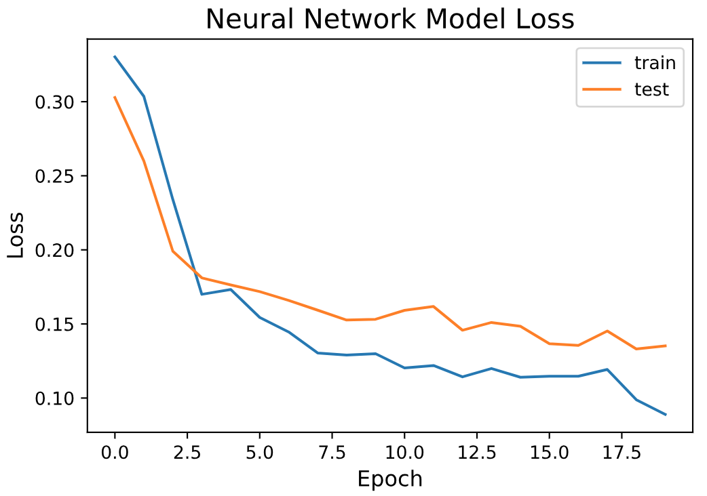



Figure Neural network learning curve

## Basic Model – Xgboost

Extreme Gradient Boosting (XGBoost) is an ensemble boosting method, which is based on the Gradient Boosted Decision Tree algorithm, but uses a more regularised model formalisation to control over-fitting. Boosting refers to the technique of adding new models to correct the mistakes of previous models. Models are added until no further improvements can be made. It is called gradient boosting because it uses a gradient descent algorithm to minimise the loss when adding new models.

XGBoost is known for its performance, speed and flexible parameter tuning. In our case, the L2 regularization is implemented to reduce the overfitting in the training period and the parameters are tuned step by step as follows:

* Fix learning rate and number of estimators for tuning tree-based parameters.
* Maximum tree depth “*max_depth*” in range (3, 10, step = 1), *max_depth*=8.
* Minimum loss reduction “*gamma*” in range (0, 0.5, step = 0.1), *gamma*=0.1.
* Tuning “*subsample*” in range (0.5, 1, step = 0.1) and “*colsample_bytree*” in range (0.6, 1, step = 0.1), *subsample*=0.51, *colsample_bytree*=0.9.
* Tuning Regularization Parameters “*alpha*” in set (0.001, 0.01, 0.1, 1, 10), *alpha*=1.
* Tuning “*reg_lambda*” in the range (1, 10, step = 1), *reg_lambda=*9.
* Reduce the Learning rate “*learning_rate*” to 0.09.





## Basic Model Comparison

Compared the best model of each algorithm, it is noted that prediction based on Xgboost can help the company earn the highest profit of 167.7 dollars for 2012, with the interest of return of 42.9%, computing by dividing cost by profit. However, it is worth to notice that the performance of Xgboost from the aspect of RMSE was not the best, worse than Neural Network.

This different indicated sign of ‘best model’ existed, since the business objective was to maximize the profit under the initial loan cost and revenue assumption instead of predicting the absolute demand.

|  |  |  |  |  |  |
| --- | --- | --- | --- | --- | --- |
|  |  |  |  | RMSE | |
| Model | Profit | Profit/Cost | Profit | Percentage Increase | Absolute Demand |
| $ million | $Increase |
| Benchmark | 145.9 | 35.7% | - | - | - |
| RandomForest | 162.6 | 39.2% | 16.7 | 0.34 | 981 |
| NeuralNetwork | 166.8 | 42.8% | 4.2 | 0.32 | 979 |
| Xgboost | 167.7 | 42.9% | 0.9 | 0.35 | 982 |

## Ensemble

As above, three single models are trained and get the performances respectively. In order to combine different models’ pros into one model, 2 major model ensemble methods blending and stacking are implemented in our case.

**Linear blending ensemble:**

Linear blending ensemble is sourced from the uniform blending. Uniform blending, which allocates the same weight to each model and calculate the average prediction as the final result. Linear blending ensemble is put forward to allocate different weights for each model through training to get the optimal linear blending model.

In our case, 2 single models Xgboost and Neural network are utilized to construct the linear blending model through training, obtain the optimal weights as 0.62 and 0.38 to minimize the RMSE and maximize the profit output.

$$Linear blending ensemble=0.62*Xgboost+0.38*Neural_Network$$

|  |  |  |  |  |  |
| --- | --- | --- | --- | --- | --- |
|  |  |  |  | RMSE | |
| Model | Profit | Cost | Profit/Cost | Percentage Increase | Absolute Demand |
| $ million | $ million |
| benchmark | 145.9 | 408.5 | 35.7% | - | - |
| blending | 168.7 | 390.6 | 43.2% | 0.33 | 949 |



**Stacking ensemble:**

In the basis of linear blending ensemble, a more complex and advanced method stacking was used in the model ensemble. The steps of constructing the stacking ensemble are listed as followed:

***Input:*** train data, test data, 3 models (neural network, random forest, Xgboost)

***Step1***: Slice the training data into 5 folds (using K-Fold)

***Step2***: For each model, ith fold is retained to be the validation, the rest 4 folds are used to train the ith base-level regressor. Use ith base-level regressor to predict the ith validation and test, then 5 validation prediction (from 1th to 5th) and 5 test prediction are generated.

***Step3***: For each model, 5 validation prediction are concat from 1th to 5th into a second-round input dataset, and 5 test prediction based on ith models calculate the average into a second-round test dataset. Therefore, 3 new pairs (input dataset, test dataset) for each model are generated.

***Step4***: Construct a meta regressor (linear regressor) to fit the input dataset, use the meta regressor to predict the test dataset and return the final test prediction result.



|  |  |  |  |  |  |
| --- | --- | --- | --- | --- | --- |
|  |  |  |  | RMSE | |
| Model | Profit | Cost | Profit/Cost | Percentage Increase | Absolute Demand |
| $ million | $ million |
| benchmark | 145.9 | 408.5 | 35.7% | - | - |
| stacking | 164.9 | 368.7 | 44.7% | 0.36 | 1136 |



# Business Performance

Among predictive models built in the previous section, the highest profit was achieved using the ensemble model which blended the best neural network and xbgboost model. The profit for 2012 was 164.9 million dollars, accounted for 44.7% of total expenditure. Compared to the benchmark, it is noted that 19 million dollars profit increase was achieved by using the *‘Best Model’*, while the return of interest lifted from 35.7% to 44.7%.

|  |  |  |  |  |  |
| --- | --- | --- | --- | --- | --- |
|  |  |  |  | RMSE | |
| Model | Profit | Cost | Profit/Cost | Percentage Increase | Absolute Demand |
| $ million | $ million |
| Benchmark | 145.9 | 408.5 | 35.7% | - | - |
| Best model | 168.7 | 390.6 | 43.2% | 0.33 | 949 |

As the business objective in this case was to help the biking sharing company gain as much profit as possible, while the revenue and the loan cost per bike were initially assumed to be $3 and $2 respectively. As such, in the model selection process, among models having the same RMSE, models with lower predicted demand than actual demand over the predicted period were selected. Thus, our best predictive model was better than the default model when revenue was around or lower loan cost. In this case, the upper limit of revenue was 3.9 dollar per bike, at which the model had the same profit for 2012 as default prediction.

$${Revenue}_{UpperLimit}= \frac{Profit_{default}+LoanCostPerBike*{Demand}_{Predicted}}{min⁡({Demand}_{Predicted},{Demand}_{Actual})}$$

Narrowing focus on predictive errors by date shown in Figure xx below, it is shown that the absolute error of rental demand had an increasing trend over 2012, which means that errors in the second half year were higher than the first half year, indicating a decrease of predictive ability with age of the model. In addition, strong seasonal influence was observed, and the performance of the model was worse in spring and winter than summer. The reason for this phenomenon was assumed to be the number of extreme weather events. From Figure xx, it is noted that months with higher absolute errors of predicted demand having relatively large number of bad weather events *(‘Type 3*’ & ‘*Type 4*’ in ‘*Weathersit*’). This was due to the inefficient number of extreme weather condition related records in the dataset. Because of this, learning algorithms were unable to predict the ‘sharp drop’ of demand in a bad weather condition.



# In order to weaken the influence of model aging, the size of training set was extended, including records from 1st January 2011 to ${31}^{th}$ June 2012, and data of the second half year of 2012 was used for testing. To compare the performance of models built on different separation of the dataset, the dataset was fitted in a random forest basic model with constant hyperparameters. The absolute errors of demand by date were shown blew in Figure xx, it is obvious that the absolute errors of the model fitted by one and a half years were much lower than one-year based model. However, the performance of these two models had become similar since November 2012, which was due to the occurrence of extreme weather events and the aging issue of the models.



# Since a training set of one and a half year records was imbalance with regards of seasonal effects, samples of the second half year of 2011 were duplicated so as to balance the training dataset. However, according to Figure xx below, there was no significant improvement achieved after data balancing.



# Conclusion

**Reference**

1. <https://www.washingtonpost.com/blogs/capital-weather-gang/post/2011-in-washington-dc-warm-with-extreme-weather-aplenty/2011/12/27/gIQAnNXSMP_blog.html>
2. <https://www.timeanddate.com/weather/usa/washington-dc/historic?month=4&year=2012>